Regression works by establishing a relationship between variables in the data that represent characteristics—known as the *features*—of the thing being observed, and the variable we're trying to predict—known as the *label*. Recall our company that rents bicycles and wants to predict the expected number of rentals in a given day. In this case, features include things like the day of the week, month, and so on, while the label is the number of bicycle rentals.

To train the model, we start with a data sample containing the features, as well as known values for the label - so in this case we need historical data that includes dates, weather conditions, and the number of bicycle rentals.

We'll then split this data sample into two subsets:

* A *training* dataset to which we'll apply an algorithm that determines a function encapsulating the relationship between the feature values and the known label values.
* A *validation* or *test* dataset that we can use to evaluate the model by using it to generate predictions for the label and comparing them to the actual known label values.

The use of historic data with known label values to train a model makes regression an example of *supervised* machine learning.

**A simple example**

Let's take a simple example to see how the training and evaluation process works in principle. Suppose we simplify the scenario so that we use a single feature—average daily temperature—to predict the bicycle rentals label.

We start with some data that includes known values for the average daily temperature feature and the bicycle rentals label.

| A simple example | |
| --- | --- |
| **Temperature** | **Rentals** |
| 56 | 115 |
| 61 | 126 |
| 67 | 137 |
| 72 | 140 |
| 76 | 152 |
| 82 | 156 |
| 54 | 114 |
| 62 | 129 |

Now we'll *randomly* select five of these observations and use them to train a regression model. When we're talking about ‘training a model’, what we mean is finding a function (a mathematical equation; let’s call it **f**) that can use the temperature feature (which we’ll call **x**) to calculate the number of rentals (which we’ll call **y**). In other words, we need to define the following function: **f(x) = y**.

Our training dataset looks like this:

| Table 2 | |
| --- | --- |
| **x** | **y** |
| 56 | 115 |
| 61 | 126 |
| 67 | 137 |
| 72 | 140 |
| 76 | 152 |

Let's start by plotting the training values for ***x*** and ***y*** on a chart:

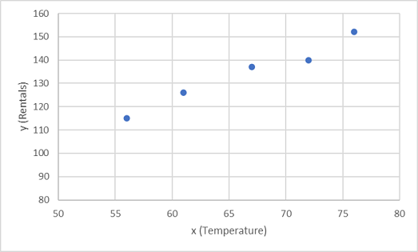

Now we need to fit these values to a function, allowing for some random variation. You can probably see that the plotted points form an almost straight diagonal line - in other words, there's an apparent *linear* relationship between ***x*** and ***y***, so we need to find a linear function that's the best fit for the data sample. There are various algorithms we can use to determine this function, which will ultimately find a straight line with minimal overall variance from the plotted points; like this:

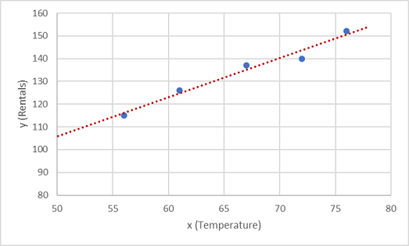

The line represents a linear function that can be used with any value of ***x*** to apply the *slope* of the line and its *intercept* (where the line crosses the y axis when ***x*** is 0) to calculate ***y***. In this case, if we extended the line to the left we'd find that when ***x*** is 0, ***y*** is around 20, and the slope of the line is such that for each unit of ***x*** you move along to the right, ***y*** increases by around 1.7. Our ***f*** function therefore can be calculated as 20 + 1.7***x***.

Now that we've defined our predictive function, we can use it to predict labels for the validation data we held back and compare the predicted values (which we typically indicate with the symbol ***ŷ***, or "y-hat") with the actual known ***y*** values.

| Table 3 | | |
| --- | --- | --- |
| **x** | **y** | **ŷ** |
| 82 | 156 | 159.4 |
| 54 | 114 | 111.8 |
| 62 | 129 | 125.4 |

Let's see how the y and ŷ values compare in a plot:

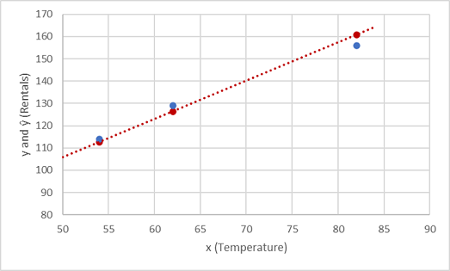

The plotted points that are on the function line are the predicted ***ŷ*** values calculated by the function, and the other plotted points are the actual ***y*** values.

There are various ways we can measure the variance between the predicted and actual values, and we can use these metrics to evaluate how well the model predicts.

Machine learning is based in statistics and math, and it's important to be aware of specific terms that statisticians and mathematicians (and therefore data scientists) use. You can think of the difference between a *predicted* label value and the *actual* label value as a measure of ***error***. However, in practice, the "actual" values are based on sample observations (which themselves may be subject to some random variance). To make it clear that we're comparing a *predicted* value (*ŷ*) with an *observed* value (*y*) we refer to the difference between them as the ***residuals***. We can summarize the residuals for all of the validation data predictions to calculate the overall ***loss*** in the model as a measure of its predictive performance.

One of the most common ways to measure the loss is to square the individual residuals, sum the squares, and calculate the mean. Squaring the residuals has the effect of basing the calculation on *absolute* values (ignoring whether the difference is negative or positive) and giving more weight to larger differences. This metric is called the ***Mean Squared Error***.

For our validation data, the calculation looks like this:

| Table 4 | | | |
| --- | --- | --- | --- |
| **y** | **ŷ** | **y - ŷ** | **(y - ŷ)2** |
| 156 | 159.4 | -3.4 | 11.56 |
| 114 | 111.8 | 2.2 | 4.84 |
| 129 | 125.4 | 3.6 | 12.96 |
|  | Sum | ∑ | 29.36 |
|  | Mean | x̄ | **9.79** |

So the loss for our model based on the MSE metric is 9.79.

So is that any good? It's difficult to tell because MSE value isn't expressed in a meaningful unit of measurement. We do know that the lower the value is, the less loss there is in the model; and therefore, the better it is predicting. This makes it a useful metric to compare two models and find the one that performs best.

Sometimes, it's more useful to express the loss in the same unit of measurement as the predicted label value itself - in this case, the number of rentals. It's possible to do this by calculating the square root of the MSE, which produces a metric known, unsurprisingly, as the ***Root Mean Squared Error*** (RMSE).

√9.79 = **3.13**

So our model's RMSE indicates that the loss is just over 3, which you can interpret loosely as meaning that on average, incorrect predictions are wrong by around 3 rentals.

There are many other metrics that can be used to measure loss in a regression. For example, **R2 (R-Squared)** (sometimes known as *coefficient of determination*) is the correlation between ***x*** and ***y*** squared. This produces a value between 0 and 1 that measures the amount of variance that can be explained by the model. Generally, the closer this value is to 1, the better the model predicts.